Category One – Imagine the Future – Sponsored by HP Inc
Compiled by Phil Oakley – Business Manager – Large Format Printing UK&I

In November 2015; HP re-imagined itself by starting afresh after 75 years in business. Splitting as two businesses to remain relevant to the world today. Starting in a humble garage in California, two friends set out on a journey to change the world.
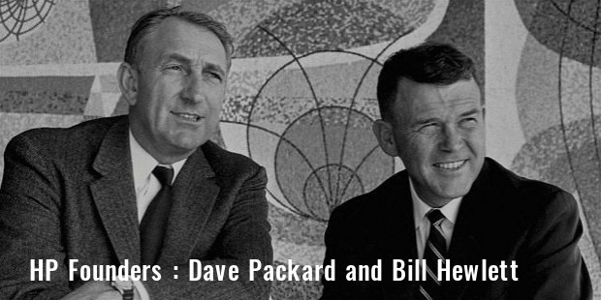
They created a working environment “The HP Way” which fostered boundless collaboration and creativity. That was in 1938 when the future outlook and trends on the surface could not be more different than today…
We are still striving for peace, connectedness, openness and transparency in life…so somethings have not changed and the main goals in life we still strive for. Changes in technology can help but three key elements must be paramount when serving any customer, community or individual. 1. Understanding. 2 Adding Value and 3. Imagining the future. The last one could be changed to one word…HOPE. Einstein once said “You cannot solve a problem on the same level it was created. You have to rise above it to the next level”. Too often we lose ground when we keep repeating what worked in the past to get success in the future. Re-imagine, reinvent and re-think what you do every day. Push the boundaries of what others expect of you and set out to create amazing experiences.
Key words & prompts:
Understanding
Adding value
Hope
Mindfulness
Amaze
Presence

Enter as many designs as you wish into a category
Enter as many categories as you wish
Recolouring of the same design is not acceptable as a subsequent entry
Do not enter the same design into more than one category
Each design should be original and not a modified version of a previous design
Ensure that all channels/layers (separations) of your work are of the same dimensions
Dimensions
Your design is to be worked up to fit one of these dimension options (table below) but can have more than one repeat within your selected option: that is to say that if your finished work measures e.g. 26.50cm x 26.50cm you must step the work up and across the sheet to fit your selected dimensions, making sure that the units match in height and width. Units can be straight or off set.
All designs must show a match in the height and width regardless of the unit size
Size | Height (cm) | Width (cm) | End Use
1 | 53 | 52 | Wallpaper
2 | 53 | 53 | Wallpaper
3 | 64 | 52 | Wallpaper
4 | 64 | 53 | Wallpaper
5 | 64 | 64 | Textiles
6 | 91.50 | 91.50 | Textiles
7 | 64 | 220 | Textiles

DO NOT SUBMIT MULTIPLE REPEATS OF A DESIGN OUTSIDE THE STATED DIMENSIONS
DO NOT MOUNT THE DESIGN ON ANY SECONDARY MEDIA E.G. CARD OR BOARD

Label your artwork discreetly, using pencil, with your name, contact details and University or College on the reverse at the bottom left corner.

Submit a digital image, showing the separate channels/layers which matches your physical entry/s exactly
The images must be supplied in jpg format only

The images must be:
- 300dpi
- 10mb maximum file size
- Maximum height and/or width at 10,000 pixels

Remember to enclose your completed & signed Entry Form and Assignment of Copyright document

