Category Three – GEO-DRAWING – Sponsored by Anstey
Compiled by – Anstey Design Studio

Geometric patterns have long been a staple of wallpaper design.
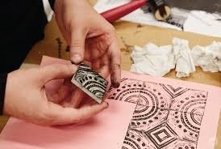
Simple shapes create rhythms on the wall that can span every mood from calming to strikingly dynamic.
But, in design, often the simplest of structures are the most difficult to create.
The precision of purely computer-generated mechanical patterns can be pleasing to the eye but for interior design they can sometimes lack character, feel lazy and soulless - not what we want on a wall in our homes.
The brief is to design a geometric wallpaper that has a hand-created element at its core by using motifs that are hand-drawn/painted, collaged or created by relief block-printing.
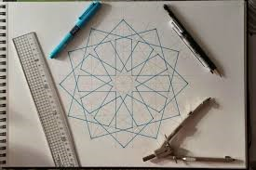
Grab a pen and some graph paper, and not just squared, there are so many different types, scales etc. of graph paper; you could even create your own…
Remember how much fun you had creating patterns with a Spirograph when you were a child?
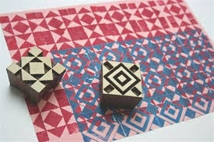
Could you build your own similar device?
What can you find around you to print with? Explore mark-making, pattern and texture through working with found objects or creating your own printing blocks.
They could be linocut, polystyrene plates or even potatoes…
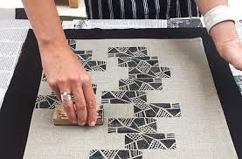
Perhaps create your own printing rollers by customising a paint roller or make a block from cardboard and sponge, carve something in clay, there are so many possibilities.
Once created, your design elements can be scanned and manipulated to create the finished wallpaper.

Suggested research – Islamic, Indian and Celtic patterns, the works of Ecsher, Bridget Riley, Victor Vasarely and Josef Albers.

Enter as many designs as you wish into a category
Enter as many categories as you wish
Recolouring of the same design is not acceptable as a subsequent entry
Do not enter the same design into more than one category
Each design should be original and not a modified version of a previous design
Ensure that all channels/layers (separations) of your work are of the same dimensions
Dimensions
Your design is to be worked up to fit one of these dimension options (table below) but can have more than one repeat within your selected option: that is to say that if your finished work measures e.g. 26.50cm x 26.50cm you must step the work up and across the sheet to fit your selected dimensions, making sure that the units match in height and width. Units can be straight or off set.
All designs must show a match in the height and width regardless of the unit size
Size | Height (cm) | Width (cm) | End Use
1 | 53 | 52 | Wallpaper
2 | 53 | 53 | Wallpaper
3 | 64 | 52 | Wallpaper
4 | 64 | 53 | Wallpaper
5 | 64 | 64 | Textiles
6 | 91.50 | 91.50 | Textiles
7 | 64 | 220 | Textiles

DO NOT SUBMIT MULTIPLE REPEATS OF A DESIGN OUTSIDE THE STATED DIMENSIONS
DO NOT MOUNT THE DESIGN ON ANY SECONDARY MEDIA E.G. CARD OR BOARD

Label your artwork discreetly, using pencil, with your name, contact details and University or College on the reverse at the bottom left corner.

Submit a digital image, showing the separate channels/layers which matches your physical entry/s exactly
The images must be supplied in jpg format only

The images must be:
- 300dpi
- 10mb maximum file size
- Maximum height and/or width at 10,000 pixels

Remember to enclose your completed & signed Entry Form and Assignment of Copyright document

