Category Two – BOHO RHYTHM – Sponsored by Arthouse
Compiled by - Arthouse Design Studio Team

Customer: A young couple moving into their first home

Theme: Boho Rhythm – We are looking for a design inspired by the eclectic patternations of a modern boho style
Embrace the relaxed and unconventional nature of bohemian decorating
Mixing patterns and textures. Layering colours, collecting treasures from around the world, all these things give boho a unique characteristic - take influence from this

Consider: Which room you are designing for and how your design will fit into the space?
Select colours to reflect the theme but be mindful of a manufacturing limit of 6 colours

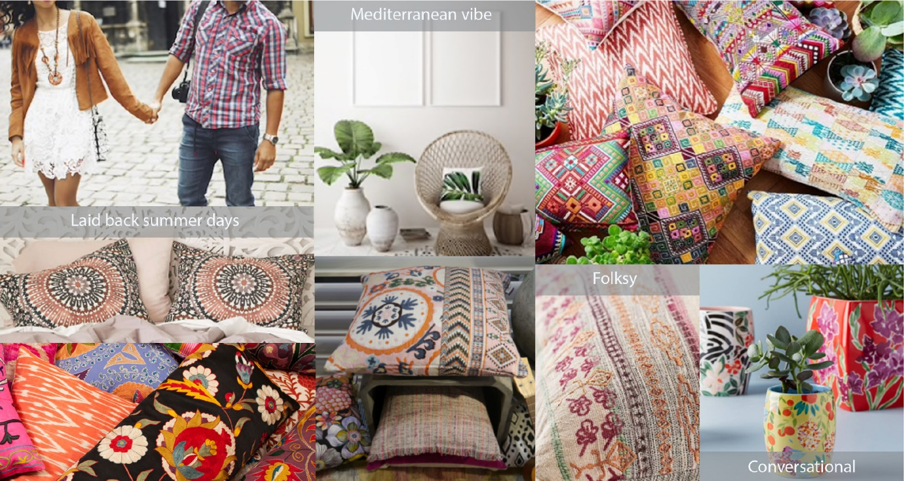

Enter as many designs as you wish into a category
Enter as many categories as you wish
Recolouring of the same design is not acceptable as a subsequent entry
Do not enter the same design into more than one category
Each design should be original and not a modified version of a previous design
Ensure that all channels/layers (separations) of your work are of the same dimensions
Dimensions
Your design is to be worked up to fit one of these dimension options (table below) but can have more than one repeat within your selected option: that is to say that if your finished work measures e.g. 26.50cm x 26.50cm you must step the work up and across the sheet to fit your selected dimensions, making sure that the units match in height and width. Units can be straight or off set.
All designs must show a match in the height and width regardless of the unit size
Size | Height (cm) | Width (cm) | End Use
1 | 53 | 52 | Wallpaper
2 | 53 | 53 | Wallpaper
3 | 64 | 52 | Wallpaper
4 | 64 | 53 | Wallpaper
5 | 64 | 64 | Textiles
6 | 91.50 | 91.50 | Textiles
7 | 64 | 220 | Textiles

DO NOT SUBMIT MULTIPLE REPEATS OF A DESIGN OUTSIDE THE STATED DIMENSIONS
DO NOT MOUNT THE DESIGN ON ANY SECONDARY MEDIA E.G. CARD OR BOARD

Label your artwork discreetly, using pencil, with your name, contact details and University or College on the reverse at the bottom left corner.

Submit a digital image, showing the separate channels/layers which matches your physical entry/s exactly
The images must be supplied in jpg format only

The images must be:
- 300dpi
- 10mb maximum file size
- Maximum height and/or width at 10,000 pixels

Remember to enclose your completed & signed Entry Form and Assignment of Copyright document

